A BENDERS-BASED APPROACH FOR SOLVING THE RESOURCE-CONSTRAINED PROJECT SCHEDULING PROBLEM
Olivier Liess*, Philippe Michelon
Laboratoire Informatique d'Avignon, Avignon, France
olivier.liess@lia.univ-avignon.fr

Abstract:
The resource-constrained project scheduling problem (a.k.a. RCPSP) consists in determining starting and finishing times for a set of activities. Each activity is defined by its duration and precedence constraints. It also consumes an amount of different scarce resources. We consider here non-preemptive scheduling (activities must be completed without being interrupted) and renewable resources (when an activity has been completed, the resources it used are freed). In the classical Benders decomposition, a well structured sub problem is identified while the remaining constraints are tackled in a Master problem. Both problems are linked by a cut generation process (i.e. the optimal solution of the sub problem is used to generate a cut in the Master problem). We present here a filtering algorithm and a branching framework based on the Benders decomposition and its cuts (although both are quite different) for the (RCPSP). Computational results on classical benchmarks of the literature are reported and compared with the State of the Art.
Keywords: RCPSP, Benders, decomposition

INTRODUCTION
While being extensively studied in the literature, the resource-constrained project scheduling problem is still considered as a difficult problem. It consists in determining starting and finishing times for a set of activities. Each activity is defined by its duration and precedence orders with other activities. It also consumes an amount of different scarce resource. We consider here non-preemptive scheduling (activities must be completed without being interrupted) and renewable resources (for each period of time, the available amount of a resource is set to its capacity). Although this problem ca n be studied in an academic way, several applications can be found, for example in production planning, building industry or in computer science.
We present here an exact method for solving the (RCPSP) consisting in a filtering algorithm and a branching framework based on Benders decomposition and its cuts. Our approach differs from the classical formulation on several points. In sections 2 and 3, we give a more precise definition of the (RCPSP) and Benders decomposition. Section 4 is an overview of the implementation of this method to the problem. We conclude this paper with computational results and thoughts about this work (sect.5).

The resource-constrained project scheduling problem
The resource-constrained project scheduling problem consists in finding the starting and finishing times of a set of activities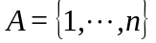minimizing the total duration of the project (a.k.a. makespan). A set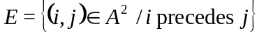defines the precedence relations between pairs of activities (i precedes j if j cannot start before the end of i). Activities are executed once, and are non-preemptive, meaning that the activity has to be processed without being interrupted before its end. A set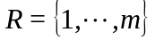of resources is also available, each resource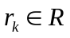having for each timea constant capacity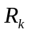. Each activity i is defined by its consumption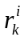of resource k, its duration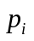, its precedence relations in E. The starting times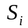of activities are the decision variables of the problem. Two dummy activities 0 and n+1 are added to represent the start and the end of the project.
This problem has been shown being NP-hard and even small instances (i.e. 30 activities and 4 resources) are difficult to solve. Therefore, only heuristics and meta-heuristics are able to find good solutions in a reasonable time. The first heuristics were based on priority rules, and works have now been published using branching algorithms, local constraints analysis, etc. Meta-heuristics are also used, for example large neighbourhood search, simulated annealing, genetic algorithms or tabu search (see Hartmann-Kolish (2000) for a State of the Art). Exact methods and lower bounds use branching algorithms, column generation, lagrangian relaxation, etc.
In this work, we use the network flow model (see Artigues (2000)):
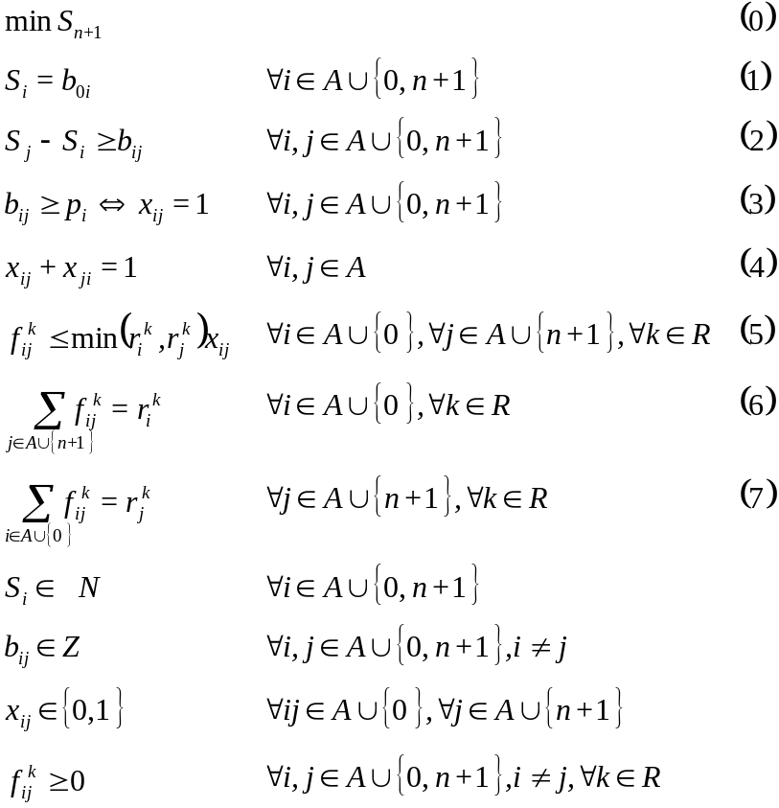
The objective function (0) minimizes the makespan. Constraints (1)-(4) correspond to the scheduling problem. 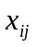defines the precedence relation between a pair of activities and 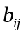are the elements of a Start-Start Distance (SSD)-matrix B (Brucker and Knust (1998)). Resource constraints are taken into account with (6)-(7) as a network flow problem. Constraint (5) links the two problems.
We can easily see that this model has a structure suited to decomposition methods. We now explain the main ideas of Benders decomposition.

Benders decomposition
Benders decomposition (Benders (1962)) starts from a mixed integer programming of the following form:
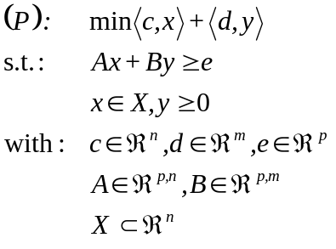
The method first separates the continuous variables from the other ones, and the continuous part is dualized for practical reasons. We obtain
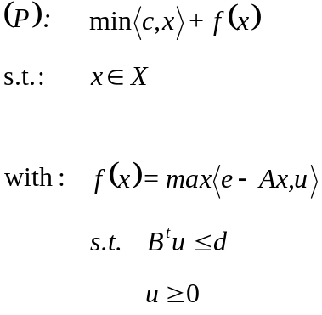
Using Minkowski's theorem:
Theorem : A non-empty polyhedron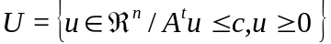 can be written as 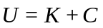, where
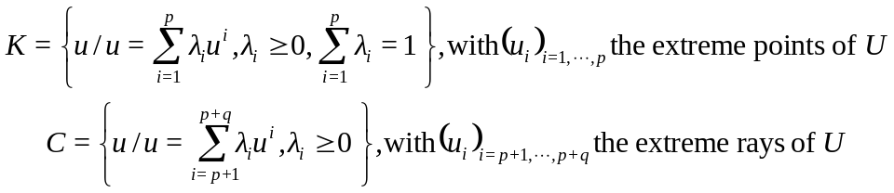
and the relations between feasible, unbounded solutions, extreme points and rays (see for example Simonard (1972) for detailed explanations), we can reformulate (P) as follows :
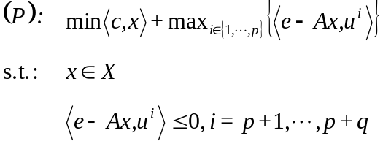
or
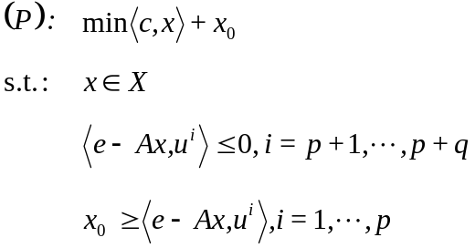

This new formulation has usually less variables that the original one, but more constraints. Benders decomposition is a relaxation where these constraints are generated iteratively. Given the master problem (MP)
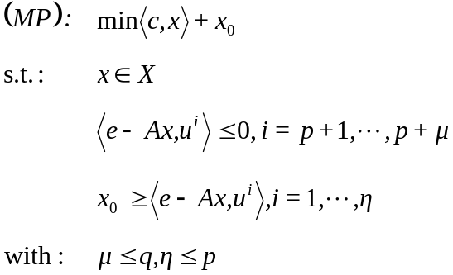
one computes at each iteration an optimal solutionof (MP). Then the slave problem (SP) can be solved, giving an optimal solution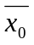.
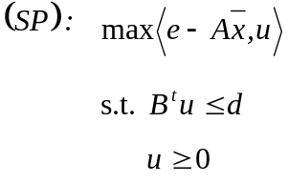
Ifis unbounded (resp. bounded) then an extreme ray (resp. point) is found and the corresponding cut is added to the master problem. An optimal solution of (P) is found when the cut is not violated by the current solution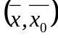.
We now apply this decomposition to the (RCPSP) using the model presented in sect. 2, and we explain the improvements made to the classical method.

Implementation
One can easily see that the (RCPSP) with resource constraints written as a network flow problem can be separated into two sub problems:
- a scheduling problem taking in account variables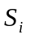,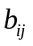and
- a network flow problem, using fixedand variables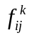.
Note that this last problem has a null objective function, being a feasibility problem instead of an optimization problem. Note also that there is no link between variables associated with different resources. Hence, we rewrite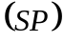as k independent sub problems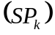. Therefore, the irrealisability ofis equivalent to the irrealisability of at least one of the sub problems. If two or more are infeasible, we can generate one cut for each infeasible, which gives a stronger reduction than the cut obtained by the union of these smaller cuts. To avoid identifying extreme rays, we reformulate these problems as minimal cost network flow problems.
Using its dual formulation
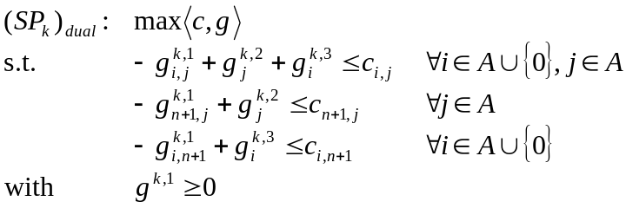
we obtain the cuts
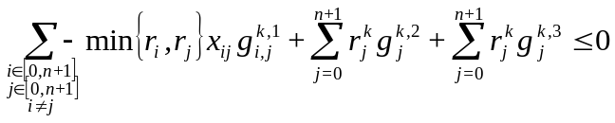
where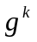are the optimal dual values of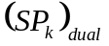.
These cuts mean that all the activities of a given set cannot be executed simultaneously. But preliminary experiments showed that these cuts are not as strong as we would like. Therefore, we replace them with cuts of the form
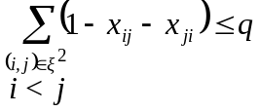
whereis a set of activities running at the same time in the current solution and q the maximal number of these activities that can be executed simultaneously without violating any resource constraint. Note that this cut is only valid if q>1. If q=1, the cut is
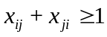
We will refer to these cuts by their signature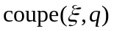. The master problem can now be formulated using constraints (0)-(4) and the cuts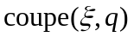. To solve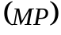, we use constraint programming (see Brucker & Knust (1998), Baptiste & Le Pape (2000)). We implemented the following algorithms:
- Floyd-Warshall computes the transitive closure of the SSD-matrix B
- Immediate selection replaces each disjunction with the corresponding precedence relation whenever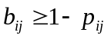.
- Symmetric triples and edge-finding identify disjunctive sets of activities and deduce precedence relations.
- A filtering algorithm taking into account the cutsgenerated during the search. Using the time period where activities from are active, the algorithm searches for activities from the setthat can’t be executed simultaneously due to their resource consumption.
As filtering is generally not enough to find the optimal solution, these algorithms are integrated in a branch & bound. We now explain improvements. In classical Benders decomposition, the master problem is solved to optimality each time a cut is found. But it is easy to see that the cuts found at a node of the branch and bound are valid for the whole search tree. Therefore, we can generate the cuts every time infeasibility is proved and continue the search without restarting it from the beginning. At the end of the search, we will have explored the domain of the master problem only once. The other improvement is about the generation of the cuts. Preliminary experiments show that, for difficult problems, the number of cuts is quickly prohibitive to apply the filtering algorithm. Consequently, we replace the filtering of these cuts by the filtering of a cut that would take into account all the active activities.

Computational results and Conclusion
To evaluate the efficiency of this framework, computational results were done using the classical benchmark for the (RCPSP) published by Kolish and we compare our method with other works.
 | Generated cuts | Global cut
j30 | 95.2% (331 nodes, 0.60s) | 96.0% (297 nodes, 0.29s)
j60 | 78.5% (44 nodes, 0.32s) | 79.4% (37 nodes, 0.17s)
Table 1.Comparison between generated cuts and global cut
% of instances solved in 30s (average number of nodes, duration)
We first see that the use of a unique cut gives better results, with an average time divided by 2.
 | Our method | Demeulemeester & Herroelen | Dorndorf | Klein & Scholl | Specher
j30 | 96.0 | 99.8 | 95.4 | 100.0 | n.p.
j60 | 79.4 | n.p. | 78.5 | 76.0 | 72.7
j90 | 78.3 | n.p. | 76.0 | n.p. | 61.5
j120 | 39.2 | n.p. | 33.3 | n.p. | n.p.
Table 2.Comparison between different methods
% of instances solved within a time limit (n.p.: non published)
The results were taken from Dorndorf (2000). Apart for small instances (30 activities), the framework seems to be quite efficient, especially for large instances.

In this paper, we have presented a framework for solving the resource-constrained project scheduling problem based on the Benders decomposition and constraint programming. Starting from the classical formulation, we exhibit ways to improve the method that can be generalised to a larger class of problems. Computational experiments on classical benchmark showed good results compared with other publications, even if the implementation of our method would need more work for fine tuning.

REFERENCES
C. Artigues (2000) Insertion techniques for on and off-line resource constrained project scheduling. Proceedings of the 7th International Workshop on Project Management and Scheduling

P. Baptiste, C. Le Pape (2000) Constraint propagation and decomposition techniques for highly disjunctive and highly cumulative project scheduling problems. Constraints, 5:119-139.

J.F. Benders (1962) Partitioning procedures for solving mixed-variables programming problems. Numerische Mathematik, 4:238-252.

P. Brucker, S. Knust (1998) A linear programming and constraint propagation-based lower bound for the RCPSP. Internal report, Universitat Osnabruck.

U.Dorndorf, E.Pesch, T.Phan-Huy (2000) A Branch-and-bound algorithm for the resource-constrained project scheduling problem. Mathematical Methods of Operations Research, 52:413-439

S.Hartmann, R.Kolish (2000) Experimental evaluation of state-of-the-art heuristics for the resource-constrained project scheduling problem. EJOR ,127(2):397-416.

M.Simonard (1972) Programmation linéaire. Dunod, Paris.

